1. The "Practice" you mentioned in the document, do we need to show the value Expertise & Sectors in the table if it’s something like selectable options as shown in the clearygottlieb? See the screenshot.

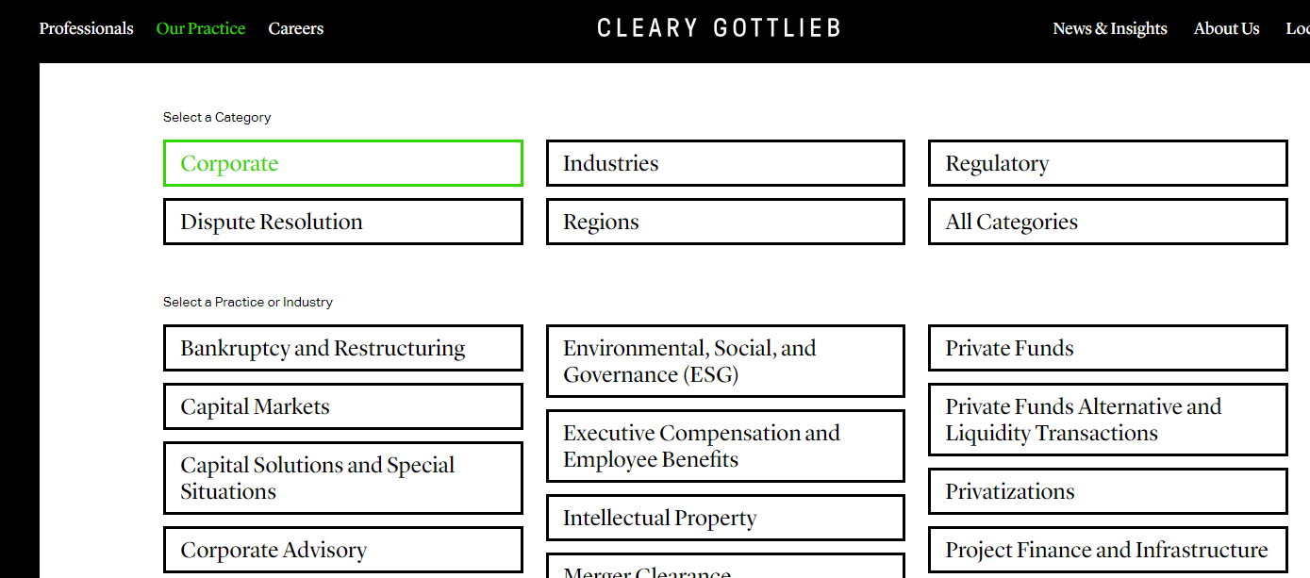

1. For “Carreers” if you can see on the clearygottlieb it shows three roles and based on the selection of roles it shows locations and by clicking on location it shows the details page. Also, the detail page contains different different types of links to open other pages.

So my question is, do you want to use the same flow? with the same content or is it’s simple single page?

Carreers Roles & Locations:

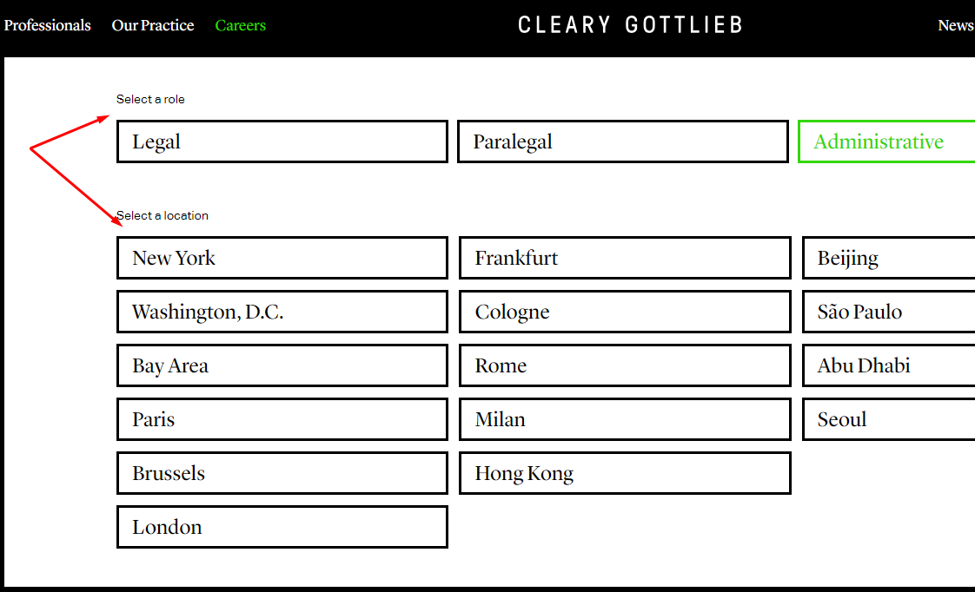

Carreers Detail Page:  
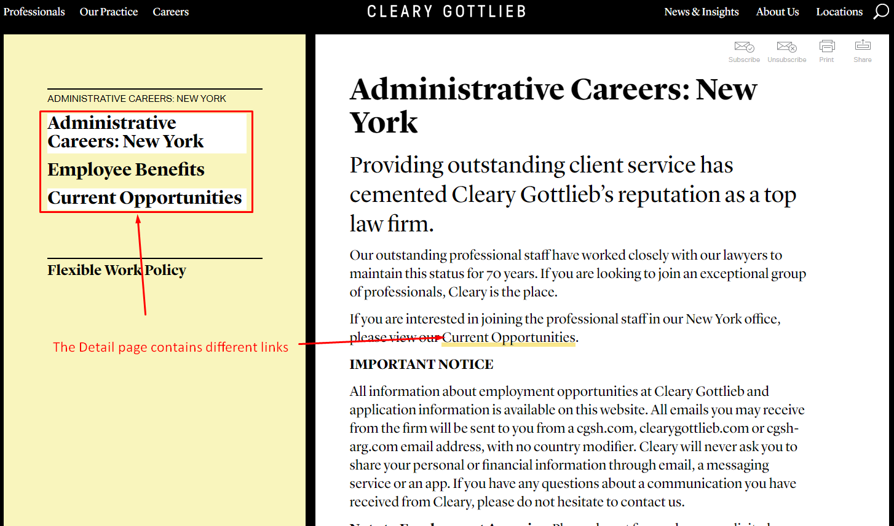

1. FYI: For now I am not considering “News and Insight”, “Disclaimer”, “Legal notice”.